My firewall of choice was OPNsense. OPNsense is an open-source firewall, it is mainly used to secure and mange network traffic through features such as packet filtering, NAT, intrusion detection etc. It comes with a web-based GUI for any configuration a user may want to, for any plugins for more improved firewall capabilities. Generally there is a bit of a learning curve with using OPNsense since you do have to know the basics of networking but it is a lot easier too use than most other firewalls. My main goal is to see how great of a firewall it is and how easy it is to access and configure rules and policies

I wanted to see how easy it was for a user to use each Firewall to block communication from untrusted VM’s. For Opnsense this was done by adding rules that permit only my “client”/administration VM’s IP to reach the destination of “this firewall” in the range of the SSH port(22) – GUI port(443). Then adding a separate rule that blocks all other hosts on the LAN network. 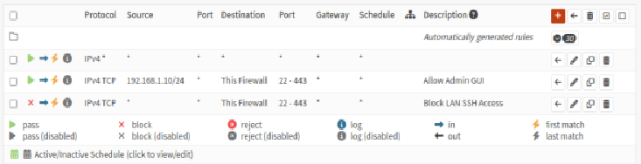

This rule simply prevents the “attacker” from accessing the GUI completely. It fully stops communication to a level where any communication attacks the attacker may try will fail 10/10 times.
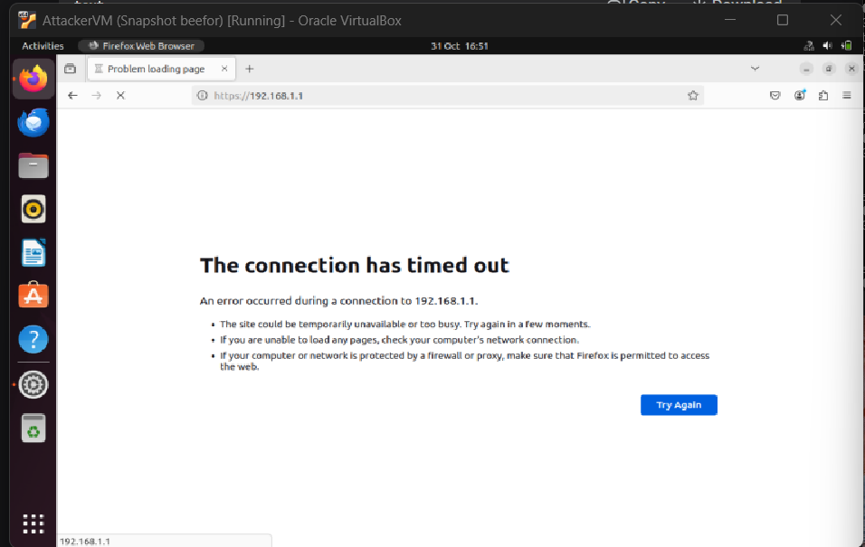

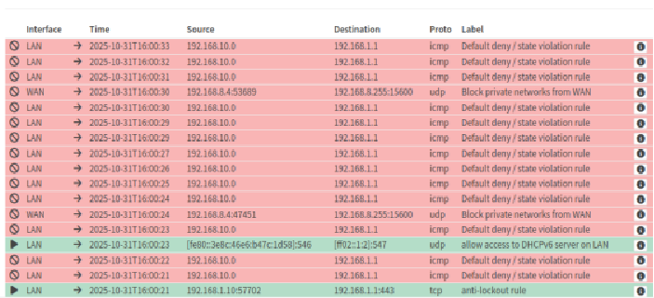
This log shows all attempts from the “attackers” attempts to try and communicate with the host, and as it is clearly labelled, it was deny access since it violates the rules.
I tried a brute force attack to see how well opnsense will deal with stopping the attacker from accessing the GUI if they tried. No matter how far into the community notes or even community pages such as reddit I went through I couldn’t at all see a rule set to limit the number of times an IP can try the password. The more and more research I did, the more I saw how tedious it was to try and add a simple password try limit to opnsense.
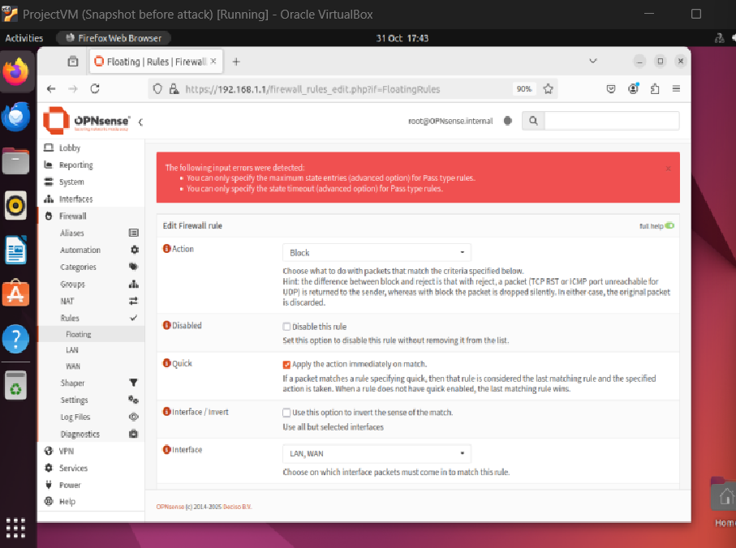
The rules don’t allow you to add a “maximum state” and a “maximum stale timeout” to any Block type rules. The maximum state rule would’ve made it so the person trying to login only has a set amount of tries to type up the password, lets say 5 simultaneous attempts, and the maximum state timeout means that OPNsense would’ve remembered each attempt for a set amount of time (60 second). This was due to the way OPNsense recognises each rule type. After a bit of research, I saw that in pass type rules, OPNsense acts as a security guard who lets people in and remembers their IP, while the block type rule simply doesn’t care for a “persons” IP and simply refuses access to wherever they were tyring to enter. This saves a ton of time and resources due to how simple and concise the block rule is. What I found a lot of people within the OPNsense community tend to do is simply not exposing their GUI to the internet and it is only accessible through a VPN. VPNs use certificate and passwords causing them to be much harder to try and brute force through, but, due to my limited resources using VM’s I wasn’t able to try this out and see how strong of a brute force preventor this setup was.

